**Lab 5: MOSFETs**

**Keegan** **Smith**

**Bench** 19

**Electronics** 1 Lab

**EECE.3110 P 1 804A**

**Date submitte**d 04/4/2022

**Due date** 04/24/2022

1. **SUMMARY**

This document contains my findings as I construct several circuits consisting with MOSFETs and observe how they function. The beginning of this procedure consists of finding the threshold voltage of the FET being used. Then, we will observe the transfer function of the transistor when an alternating current is supplied to it. After that, a simple amplifier will be constructed with the FET and a standard NPN transistor.

1. **EQUIPMENT**

|  |  |  |
| --- | --- | --- |
| **Equipment Type** | **Details** | |
| * Oscilloscope | *Make:* | InfiniiVision |
| *Model:* | DSO-X2004A |
| *Serial Number:* | MY52161432 |
| * Digital Multimeter | *Make:* | Keithley |
| *Model:* | 2110 5½ |
| *Serial Number:* | 8004026 |
| * DC Power Supply | *Make:* | GWInstek |
| *Model:* | GPD-3303D |
| *Serial Number:* | EM840514 |
| * Function Generator | *Make:* | Tektronix |
| *Model:* | AFG1022 |
| *Serial Number:* | AFG102217331728 |
| * Analog Discovery | *Make:* | Digilent |
| *Model:* | Analog Discovery 2 |
| *Serial Number:* | 210231B0DF82 |
| * Breadboard * Bench “Shoebox” with connector cables, adapters, clips etc. | N/A | |

**Table 1. Equipment**

**Table 2. Components**

|  |  |  |
| --- | --- | --- |
| **Component Type** | **Quantity** | **Details** |
| Resistor | 1 | 1kΩ |
| Resistor | 1 | 3.9kΩ |
| Resistor | 1 | 5.6kΩ |
| Resistor | 1 | 39kΩ |
| Resistor | 1 | 56kΩ |
| Capacitor | 1 | 1µF |
| Capacitor | 1 | 10µF |
| MOSFET | 1 | 2N7000 N-channel |
| Transistor | 1 | 2N3904 NPN |

1. **INTRODUCTION**

MOSFETs, also known as metal oxide semiconductor field-effect transistors, are a type of semiconductor that works like a faucet; the current allowed through the device is controlled by the gate voltage level. As simple as this sounds, these devices take extreme precision to construct and hundreds of millions of FETs can be found in every electronic device.

In the first section of the lab, a simple circuit is built with a LED on the drain of the FET. Gradually, the voltage on the gate will be increased and the LED will slowly begin to light. This is a visual representation of the threshold voltage. This voltage is when the gate begins to “close”, and current is allowed to flow from the source to the drain. The voltage on the gate of the MOSFET when the diode is fully lit, is the turn on voltage, or threshold voltage, of the field-effect transistor.

The second section is visualizing the characteristic curve for a MOSTFET. During this part, an amp-meter is connected in series to the drain of the FET and the voltage is slow increased in 0.1V increment, allowing for the recording of the data. Once all the data is collected, it can be imported onto a computer and visualized using MATLAB.

Part three of the procedure is constructing an amplifier and using the MOSFET as a voltage-controlled resistor. Using a voltage divider between the FET and a 3.9kΩ resistor on the emitter of the NPN transistor, the gain of the amplifier can be adjusted by changing the voltage on the gate of the field-effect transistor.

1. **CIRCUIT DESCRIPTION**

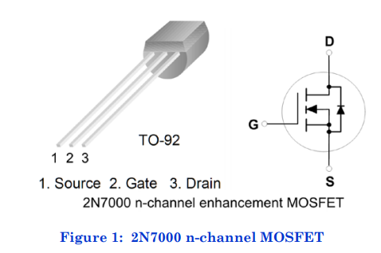

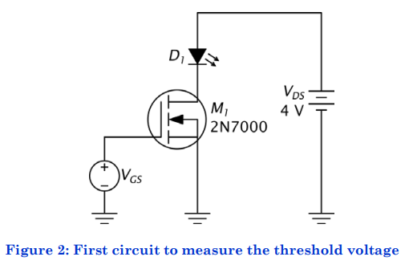

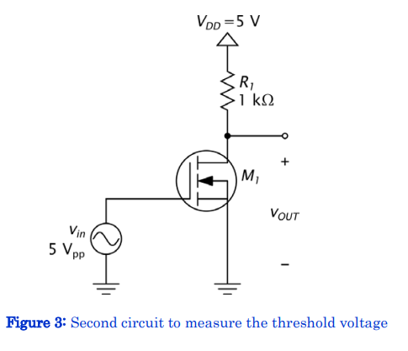

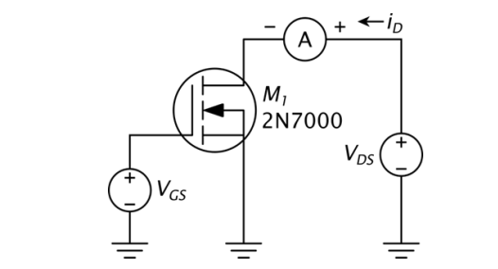

**Figure 4. circuit used to measure characteristic Curve of FET**

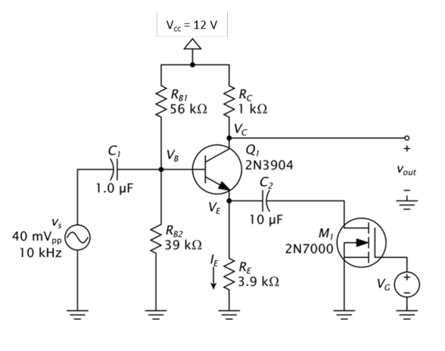

**Figure 5. MOSFET amplifier circuit**

1. **MEASUREMENTS**

**Table 2. Characteristic Curve Current vs. Voltage Measurements**

|  |  |  |  |  |  |  |  |  |  |  |  |  |  |
| --- | --- | --- | --- | --- | --- | --- | --- | --- | --- | --- | --- | --- | --- |
| **VGS** | **VDS** | **0** | **0.1** | **0.2** | **0.3** | **0.4** | **0.5** | **0.6** | **0.7** | **0.8** | **0.9** | **1.0** | **Units** |
| 1.0v | | 0 | 0 | 0 | 0 | 0 | 0 | 0 | 0 | 0 | 0 | 0 | mA |
| 1.8v | | 0 | 0.005 | 0.005 | 0.005 | 0.005 | 0.005 | 0.005 | 0.005 | 0.005 | 0.005 | 0.005 | mA |
| 2.1v | | 0 | 0.168 | 0.20 | .210 | 0.215 | 0.218 | 0.220 | 0.222 | 0.224 | 0.225 | 0.226 | mA |
| 2.4v | | 0 | 0.737 | 1.427 | 2.80 | 2.90 | 2.90 | 3.0 | 3.0 | 3.1 | 3.2 | 3.3 | mA |

**Table 3. Resistor Measurements for Part 3.**

|  |  |  |  |  |
| --- | --- | --- | --- | --- |
| **Resistor** | **R­B1** | **RB2** | **RC** | **RE** |
| **Listed Value** | 56 kΩ | 39 kΩ | 1 kΩ | 3.9 kΩ |
| **Measured Value** | 54 kΩ | 37 kΩ | 0.97 kΩ | 3.8 kΩ |

**Table 4. DC Voltage Measurements**

|  |  |  |  |  |  |
| --- | --- | --- | --- | --- | --- |
| **DC Quantity** | VB | VE | IE | VC | VCE = VC - VE |
| **Computed Value** | 4.92v | 4.22v | 1.082mA | 10.89v | 6.67v |
| **Measured Value** | 4.8325v | 4.192v |  | 10.93v | 6.745v |

**Table 5. Measured Gain When VG is from 1.0v to 2.0v in 0.1v increments**

|  |  |  |
| --- | --- | --- |
| **VG** | **VOUT** | **AV** |
| **1.0** | 0.01225 | 0.30625 |
| **1.1** | 0.01195 | 0.29875 |
| **1.2** | 0.01125 | 0.28125 |
| **1.3** | 0.01295 | 0.32375 |
| **1.4** | 0.01192 | 0.29800 |
| **1.5** | 0.01225 | 0.30630 |
| **1.6** | 0.01325 | 0.33125 |
| **1.7** | 0.01493 | 0.37325 |
| **1.8** | 0.01927 | 0.48175 |
| **1.9** | 0.03530 | 0.88250 |
| **2.0** | 0.08040 | 2.01000 |

**Figure 6. Measured Transfer Function of Figure 3**

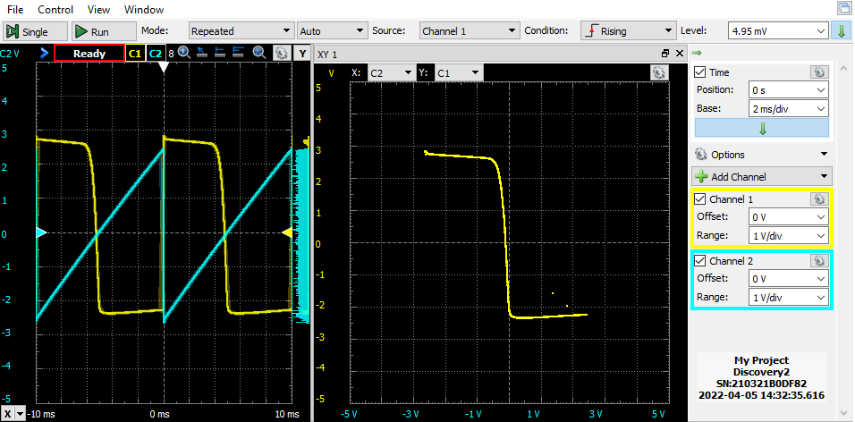

**Figure 7. Characteristic Curves with different VD**

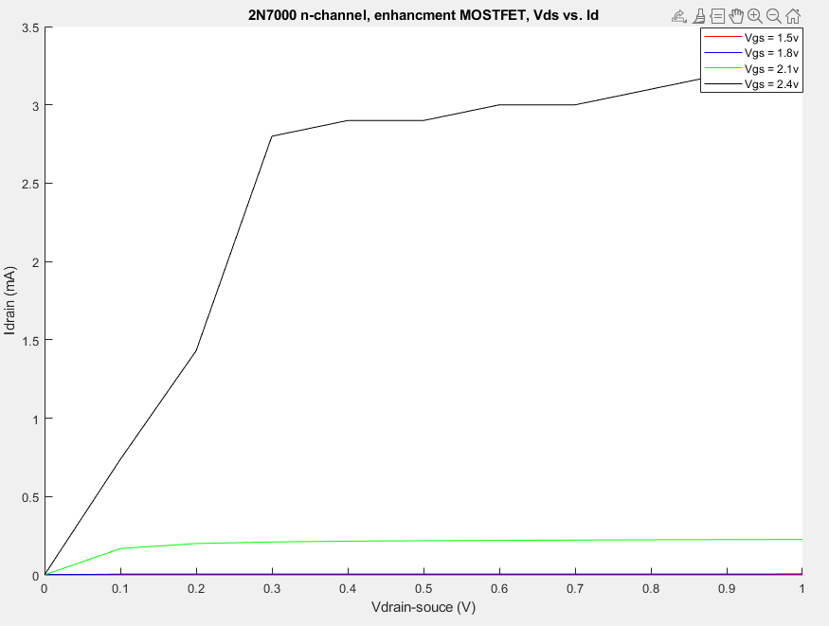

**Figure 8. Amplifier Output with V­G = 2 volts**

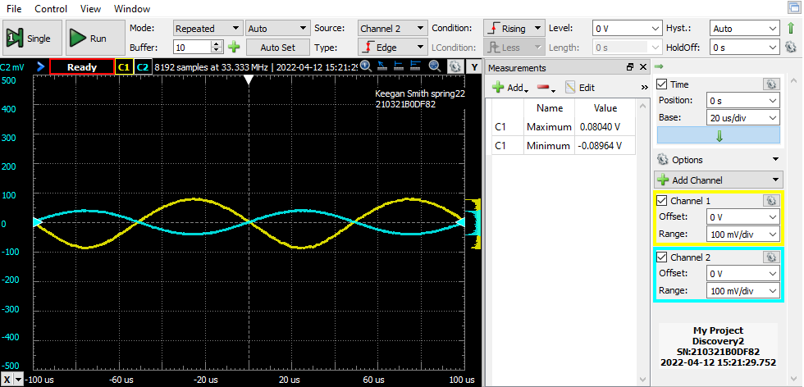Here the input to the amplifier is channel 2 and the output is channel 1.

1. **DISCUSSION**

The first part of section one in the lab experiment is finding the threshold voltage of the MOSFET in use. This is done by constructing figure 2, and slowly increasing VGS from 0v to 4v. As the threshold voltage of the transistor is neared, the LED will get brighter and brighter, being the brightest once the FET reaches its threshold voltage. I found the LED to be brightest at VGS equal to 2.6v. After this, figure 3 is constructed and the threshold voltage is found an alternate way to verify the previous results. The result of the second part can be seen in figure 6, the measured transfer function.

Section two of the procedure is about creating the characteristic curve of the MOSFET. This is done by recoding IDrain at VDS equal to 1.5, 1.8, 2.1, and 2.4 volts while incrementing VGS from 0 to 1.0 volts. After that, Matlab is used to plot the data from the different VDS values. My data can be seen in figure 7.

The last part of the laboratory procedure is looking at the MOSFET being used as a voltage-controlled resistor. This works because the FET has a linear current-to-voltage relationship in the aptly named “ohmic” region. By operating in this region of the FET we can control the amplification of the bipolar-junction transistor, controlling the “volume” of the circuits output.

1. **CONCLUSION**

During the second part of the first section, my measured transfer function did not look exactly like figure 4, and I suspect this is due to an amalgamation of tolerances from all the components in the circuit. Another discrepancy is from the data acquired in section two of the procedure, my current readings for VGS equal to 1.8v and 2.1v do not match what is in figure 6. This could be due to tolerances on components or there was an error in the circuit construction. Despite these slight differences the data acquired and observed throughout this procedure aligns with the theory learned during class.

1. **QUESTIONS**
2. See questions throughout the lab.
   1. How do the values of the threshold voltage in parts 1(a) and 1(c) compare?
      1. The values measured in 1(a) and 1(c) were 2.6 and 2.5 volts respectively.
   2. Do these values fall within the specifications?
      1. These threshold voltages do fall withing specification from the MOSTFET’s datasheet. The datasheet has a max threshold voltage of 3v listed.
3. You measured the drain current rather than the source current in this lab. What is the difference between the source current and the drain current?
   * 1. The difference between the source and drain current to a MOSFET is that the source current is the current over the body of the FET, whereas drain current is the actual output of the device.
4. **REFERENCES**

Figures 1-5 taken from the lab procedure